**NAME : P.Bali Reddy**

**REGISTER NUMBER : 192110732**

**COURSE CODE : CSA0520**

**COURSE NAME : DATABASE MANAGEMENT FOR DATA ANALYTICS**

##### Program 1:

Write a function that uses CASE statement where if monthly_value is equal to or less than 4000, then income_level will be set to 'Low Income'. If monthly_value is equal to or less than 5000, then income_level will be set to 'Avg Income'. Otherwise, income_levelwill be set to 'High Income'.

##### Procedure:

LOOP Syntax [begin_label:] LOOP statement_list

END LOOP [end_label]

LOOP implements a simple loop construct, enabling repeated execution of the statement list, which consists of one or more statements, each terminated by a semicolon

(;) statement delimiter. The statements within the loop are repeated until the loop is terminated. Usually, this is accomplished with a LEAVE statement. Within a stored function, RETURN can also be used, which exits the function entirely.

##### Program 2:

Write a function that will use ITERATE statement which would cause the loop to repeat while income is less than 4000. Once income is greater than or equal to 4000, would terminate the LOOP.

1)

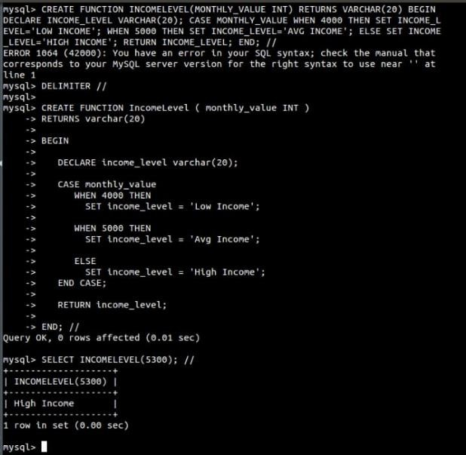

2)

